Tube Furnace with controller and inert gas purging system

Indo Furnaces (IAM) offers a broad selection of Tube furnaces in convenient styles, sizes and temperature ranges for laboratory use.
This line has different sizes, temperature and Vacuum/Inert gas medium heating, Split type or Box type furnaces; all designed to provide convenient Furnaces for laboratory procedures that must be performed under Vacuum/inert gas or in air medium at elevated temperatures.

Many of these Tube Furnaces are offered with ceramic/Quartz tubes with an inert gas purging arrangements at both ends of Tube with fittings on Silicon rubber with cooling arrangement. These can be supplied with quartz/ceramic boats to be used to keep samples.

Heating elements: Kanthal A1 and MoSi₂

User must check the vapor pressure at operating temperature to ensure that operating conditions are within safety limits.

Material details:
Tube material: Ceramic tube/ quartz tube

End Flange material: Tubular furnace with gas purging system and water circulation at end fittings

Box type tube Furnace with PID controller and inert gas purging system
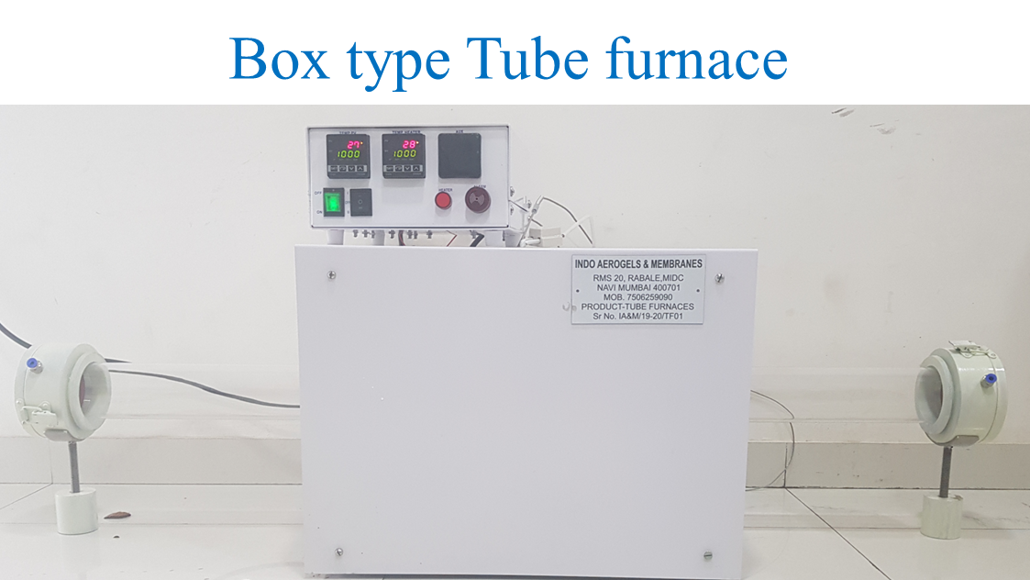

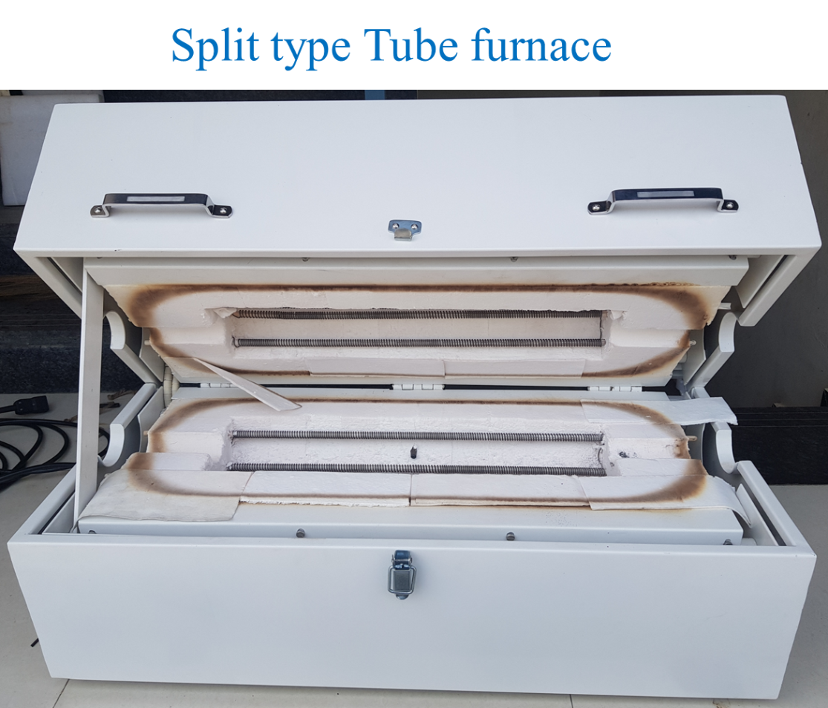

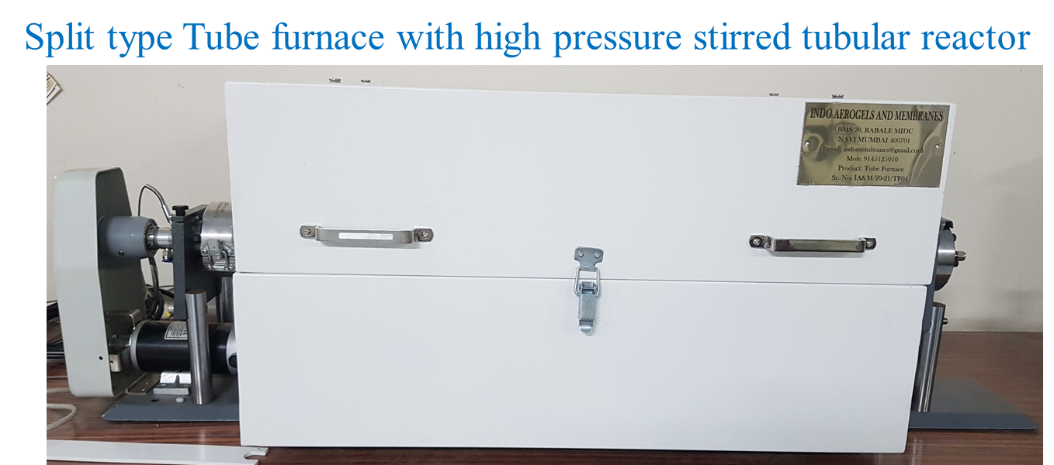

Furnace Temperature 600 - 1800 ºC
Single heating zone
Model* | Heating Length (Inch) | Wattage | Voltage | Overall dimension (cm) | Bore diameter (cm)
Indo-12S | 12 | 1,300 | 230 | 40x30.5x43 | 2.5, 5, 7.5
Indo-12F | 12 | 2,600 | 230 | 40x30.5x43 | 2.5, 5, 7.5
Indo-18S | 18 | 3,000 | 240 | 53x48x43 | 2.5, 5, 7.5
Indo-24F | 24 | 3,400 | 240 | 53x48x43 | 2.5, 5, 7.5
Indo-24S | 24 | 4,710 | 240 | 65x48x43 | 2.5, 5, 7.5
Indo-36F | 36 | 6,194 | 240 | 105x48x43 | 2.5, 5, 7.5

*Indo-12S/F- 12inch heating zone, S-Slow heating or F- fast heating

Technical Specifications:

Product Name: tubular Furnace

Model: Indo/24S

Sr. No. | Technical Parameter | Technical range/values
 | Maximum temperature | 1200 °C
 | Working temperature | 1200 °C
 | Controlling Thermocouple | K type, N Type
 | Length | 800 mm
 | Width | 450 mm
 | Height | 550 mm
 | Weight | 150 Kg
 | Heating element | Kanthal A1
 | Optional Accessories | Gloves, Heating Element, Tongs, Pirani Gauge, Vacuum Pump, Vacuum Fitting, Solenoid Valves
 | Tube material | Quartz
 | External Chamber Construction | MS Powder Coated
 | Insulation | Cervac Board
 | Flange | Stainless steel/ Aluminium
 | Flange cooling | Water circulation
 | Gaskets | Viton/Silicone gaskets

Photos of Tubeular Furnace Model: Indo/24S

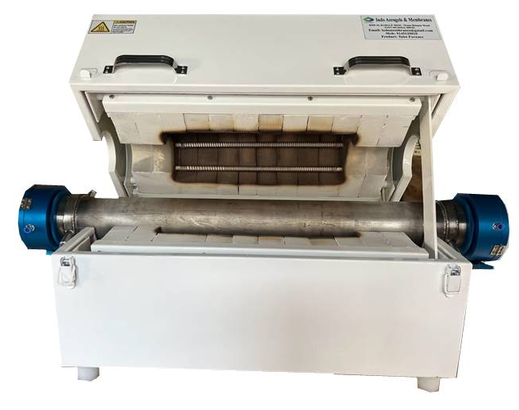
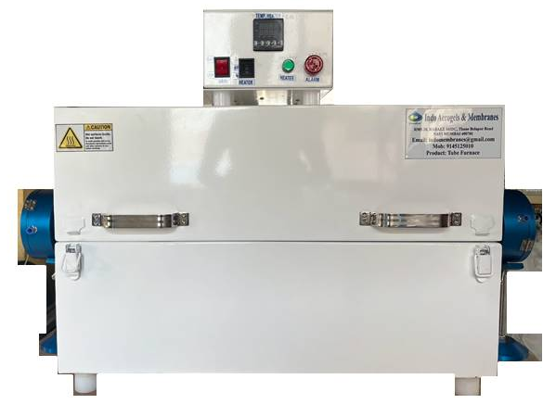
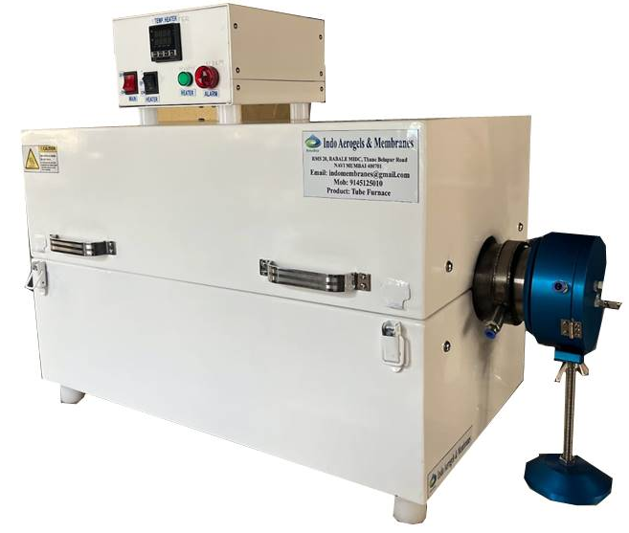
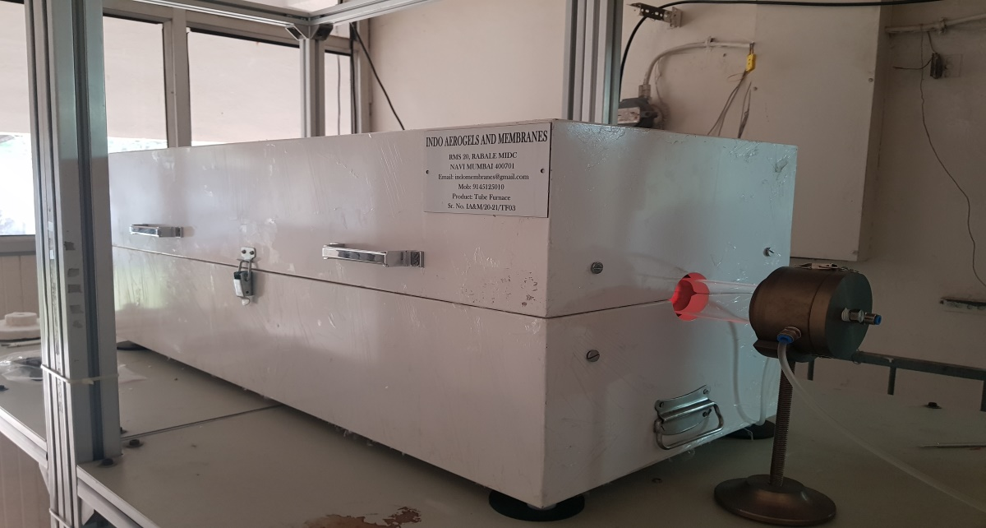

Controller 4X48

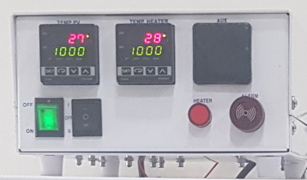 | - The controller can be provided with  Four slots (48x48) or  Five slots (Three 48x48 , Two 48x24)  - PID (Proportional - Integral - Derivative) with Ramp & Soak  - Vessel surface temperature display  RS 485 interface

Microprocessor controllers operate with three different modes.
PID (Proportional - Integral - Derivative)
Proportional-Integral-Derivative Systems have three control functions.
Proportional control adjusts the heating in proportion to the temperature difference from the set point. Integral function compensates for any temperature control offset from the set point. The derivative function deals with the rate of change of the temperature.
This control can rapidly bring a system to a desired temperature with little or no overshoot and smooth, continuous regulation. These controllers are now self-tuning so that they can set the proportional band, compensate for any offset and adjust the proportional action to ensure that the temperature in the controlled system will be held at the set point with minimal deviation.

Ramp and Soak Programming
This control option allows the operator to program a time and temperature profile into the controller for automatic execution. This can consist of a series of different temperature settings and the length of time each is to be held. The rate of change from one setting to another can also be controlled if the changes are within the capability of the heating and/or cooling system. An additional feature provides for control of the approach to a critical temperature when over- shoots cannot be tolerated. A visual display prompts for all programming and timing functions.

Control Module Specifications
Operating Range 0-1200° C
Digital Readout Resolution 1° C
Digital Set point Resolution 1° C
System Accuracy +/-2° C
High Limit Alarm Red LED and Audio
Thermocouple Burnout Prot. Yes
Thermocouple Type K
Communications Module Serial port RS485

